**30-Sep-2024**

**Internship Day – 51 Report:**

Test Of CCNA Lab

**1-Oct-2024**

**Internship Day – 52 Report:**

**What is Open Source?**

Open source software is built on the principles of transparency, collaboration, and user freedom, allowing anyone to use, modify, and share the software, often under licenses that ensure these freedoms while enabling community-driven innovation and continuous improvement.

**Key Points on Linux Origins:**

* **1984**: The **GNU Project** and **Free Software Foundation** were established, aiming to create an open-source version of UNIX utilities and introducing the **General Public License (GPL)**, a license enforcing open-source principles.
* **1991**: **Linus Torvalds** developed an open-source, UNIX-like kernel, also licensed under the GPL, and integrated GNU utilities, seeking community support online.
* **Today**: The **Linux kernel combined with GNU utilities** forms a complete, open-source, UNIX-like operating system. It's packaged into various **distributions** tailored for specific users and needs.

**Why Linux?**

* **Open Source**
* **Community Support**
* **Highly Customizable**
* **Server Dominance**
* **DevOps Integration**
* **Automation**
* **Security**

**Architecture of Linux:**

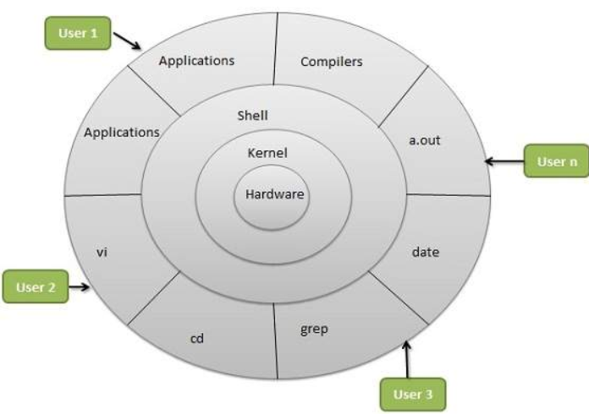

**Some Importaznt Directories:**

* **Home Directories: /root, /home/username**
* **User Executable: /bin, /usr/bin, /usr/local/bin**
* **System Executables: /sbin, /usr/sbin, /usr/local/sbin**
* **Other Mount points: /media, /mnt**
* **Configuration: /etc**
* **Temporary Files: /tmp**
* **Kernels and Bootloader: /boot**
* **Server Data: /var, /srv**
* **System Information: /proc, /sys**
* **Shared Libraries: /lib, /usr/lib, /usr/local/lib**

**Different Linux Distributions:**

**Desktop Linux OS:**

* Ubuntu: User-friendly, strong community, frequent updates.
* Linux Mint: Stable, beginner-friendly, based on Ubuntu.
* Arch Linux: Minimalist, customizable, rolling-release.
* Fedora: Cutting-edge, developer-focused, Red Hat-sponsored.
* Debian: Stable, versatile, widely used in desktop/server.
* OpenSUSE: Robust system management, developer-friendly.

**Server Linux OS:**

* **Red Hat Enterprise Linux (RHEL):** Enterprise-grade, stable, secure.
* Ubuntu Server: Scalable, flexible, popular in cloud environments.
* CentOS: Free RHEL alternative, community-driven, stable.
* SUSE Enterprise Linux: High performance, enterprise-focused.

**Most Used in IT:**

* RPM-based: RHEL, CentOS (enterprise, stability).
* Debian-based: Ubuntu Server (cloud, DevOps, flexibility).

**Linux Commands**

**File and Directory Operations:**

* 1. **ls:** Lists all files and directories in the current directory.  
       
     
  2. **cd:** Changes the current directory to the specified directory.

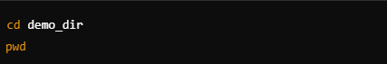

* 1. **pwd:** Prints the current working directory, showing the full path of the directory you are in. Useful for confirming your location within the file system.



* 1. **mkdir:** Creates a new directory with the specified name.

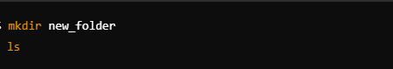

* 1. **rm:** Remove files  
       
     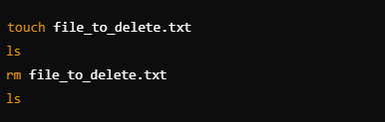

* 1. **rm -r:** Recursively removes a directory and all of its contents.  
       
     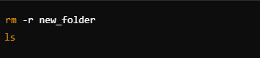
  2. **cp:** Copy files   
       
     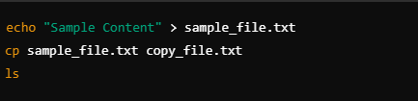
  3. **mv:** Move or rename files.  
       
     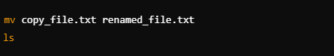
  4. **touch**: Create an empty file.  
       
     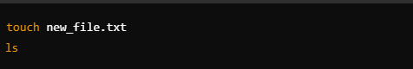

**3-Oct-2024**

**Internship Day – 53 Report:**

**File Viewing and Editing:**

* **cat:** Displays the entire contents of a file.  
    
  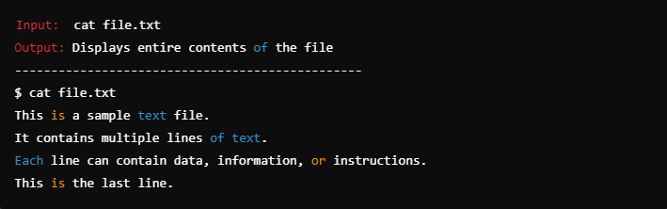
* **nano or vim:** Command-line text editors for creating and editing files.  
    
  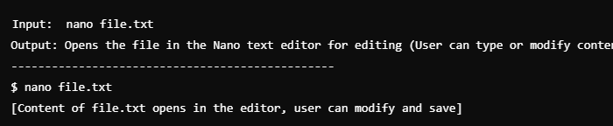  
    
  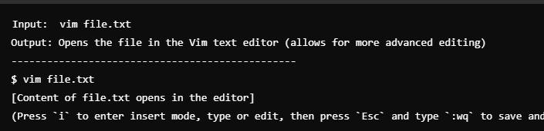

**Filter Commands:**

* **head:** Shows the first few lines of a file (default is 10 lines).  
    
  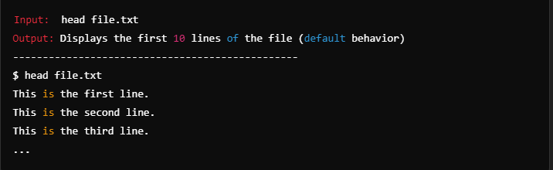
* **tail:** Shows the last few lines of a file (default is 10 lines).  
    
  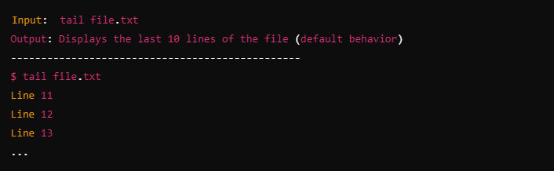
* **less:** Allows you to view file contents page by page with scrolling.  
    
  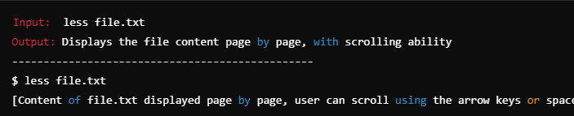
* **more:** Displays file content one screen at a time, allowing you to scroll down through long files using the spacebar.  
    
  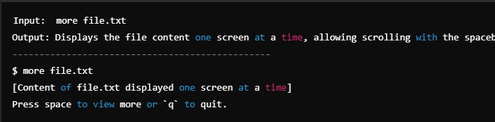
* Display First 5 Lines and Pipe to less:  
    
  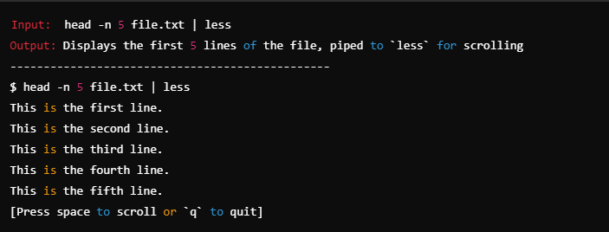

**4-Oct-2024**

**Internship Day – 54 Report:**

**System Information:**

* **uname -a:** Displays detailed system information, including the kernel name, version, and system architecture.  
    
  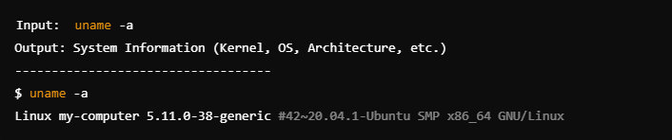
* **df:** Shows disk space usage for all mounted filesystems; use `df -h` for human-readable format (e.g., GB, MB).  
    
  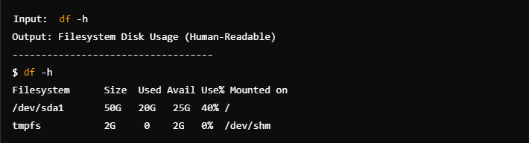
* **top:** Displays a real-time view of running processes, CPU, and memory usage, helping monitor system performance.  
    
  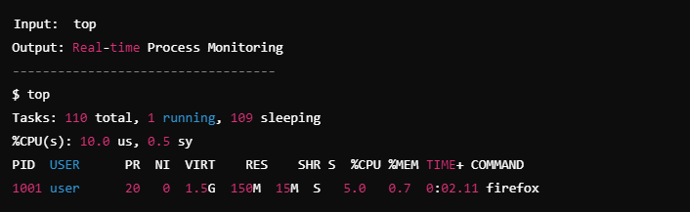
* **ps:** Lists currently running processes; use `ps aux` for detailed information about each process.
* **whoami:** Outputs the current user’s username, indicating who is logged into the session.

**File Permissions:**

* **chmod**: Changes file or directory permissions, allowing you to set read, write, and execute permissions for the owner, group, and others.  
    
  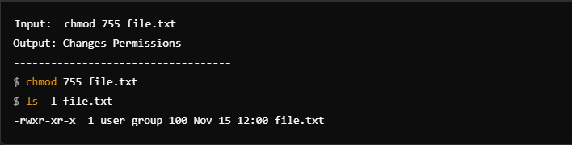
* **chown**: Changes the ownership of a file or directory, assigning a different user or group as the owner.

**Network:**

* **ping**: Sends packets to another network host to check connectivity and measure response time, useful for network troubleshooting.  
    
  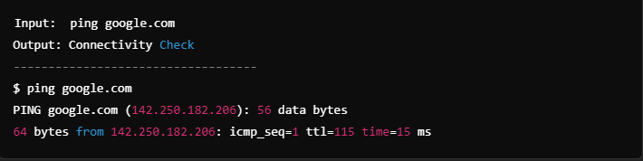
* **ifconfig** or **ip addr or ip addr show**: Displays network interface configurations, including IP addresses, network masks, and MAC addresses.  
    
  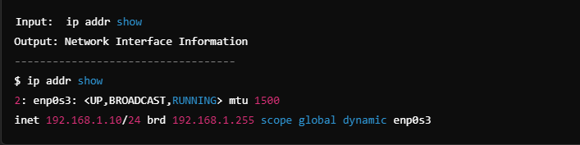
* **ssh**: Provides secure remote login to another machine over a network, commonly used for remote administration.

**Package Management:**

* **apt-get** (Debian/Ubuntu) or **yum** (Red Hat/CentOS): Installs, updates, or removes software packages from the system’s package repositories.
* **apt-get update**: Refreshes the package list, ensuring access to the latest versions available in the repositories.  
    
  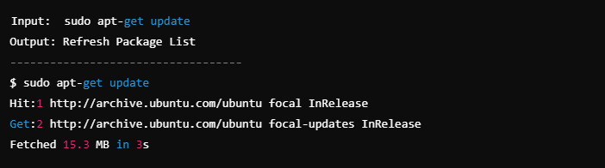
* **apt-get install**: Installs specified packages from the repository, resolving and downloading dependencies automatically.  
    
  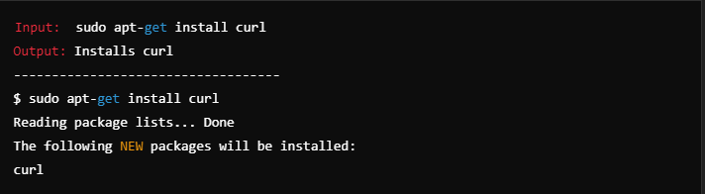

**Other Useful Commands:**

* **man**: Displays the manual page for a command, providing detailed information and usage options.  
    
  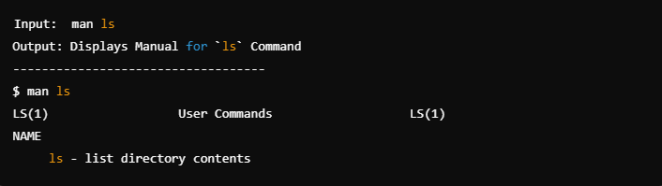
* **grep**: Searches files for lines that match a specified pattern, often used for text processing and filtering.  
    
  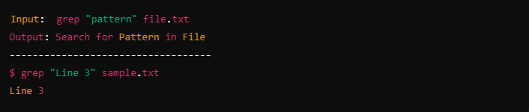
* **sudo**: Runs commands with superuser privileges, required for tasks that affect system settings or protected files.
* **clear**: Clears the terminal screen, providing a clean workspace.  
    
  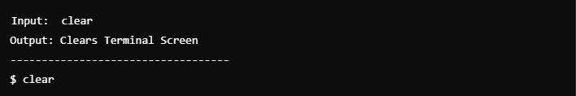
* **history**: Lists previously executed commands in the terminal session, allowing easy recall or re-execution of commands.  
    
  